
a
Company
Logotype

Cone Beam Computed Tomography- Report



Porur Dental X-rays & CBCT

Patient Name : Mrs. Vijayalakshmi | Date of Report : 12.08.2024
Age/ Gender : 31 years/ Female | Region of Interest : CBCT Sectional Maxilla
Referring doctor: Prof. A. Venkatachalapathy | Indication : Implant assessment
Clinical Notes: Nil
PATIENT INFORMATION

CBCT- Sectional Maxilla provided
CBCT – IMAGE DETAILS

RADIOGRAPHIC INTERPRETATION

- Completely missing crown and root portion in relation to 12.
- The maxillary alveolar ridge in relation to 12 is present with normal trabecular pattern.
 | 12 region
Sub-Crestal | 6.49
Mid- Crestal | 5.68
Distance between the alveolar ridge and Floor of the Nasal cavity (in mm) | 20.68
IMPLANT ASSESSMENT

RADIOGRAPHIC IMPRESSION

- Partially edentulous maxillary arch.

Kindly correlate with clinical findings


IMAGES FOR REFERENCE

RECONSTRUCTED PANORAMIC VIEW
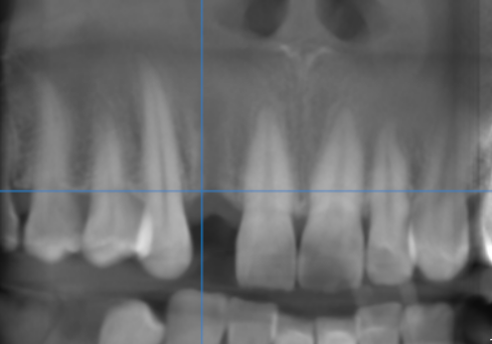

3-DIMENSIONAL VIEW

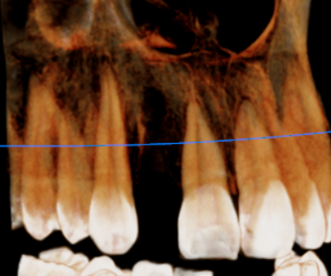

CROSS SECTIONAL VIEW

12 region | 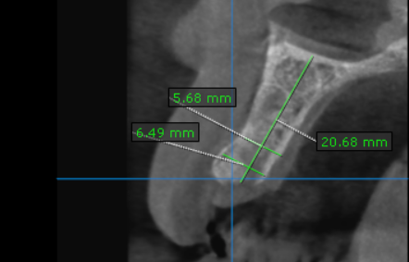

**** End of report ****

